Bash Scripting First Video Tasks

echo $0 : This command is used to know the in which shell we are present

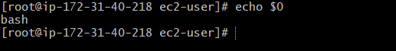

cat /etc/shells: This will give how many shells are in our linux system.

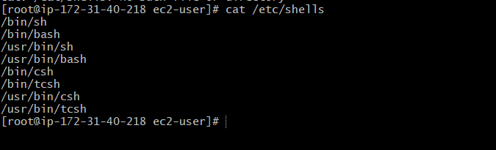

Print Hello World Script:

#!/bin/bash
#Hello World Print message
echo = “Hello World”

Command: vi helloworld.bash

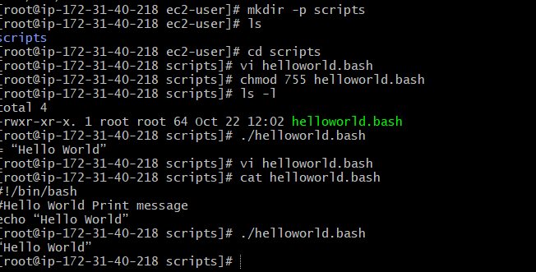

Defining Tasks:

#!/bin/bash
#Defining Small Tasks
#Date: 22-10-2026
whoami # knows the user name
echo
pwd # knows the present working directory
echo
hostname # Gives the host name of the linux machine
echo
ls -ltr # Gives list of files in th long format on oldest to newest

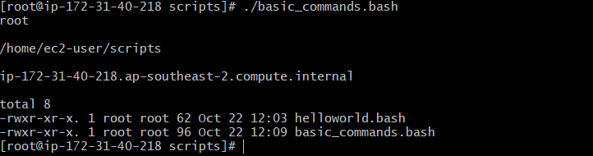

Defining Variables:

#!/bin/bash
#Examples for defing a variables
a = Surya
b = Devops
c = ‘bash Scripting’
echo “My name is $a”
echo “Training on $b”
echo “Present Concept $c”

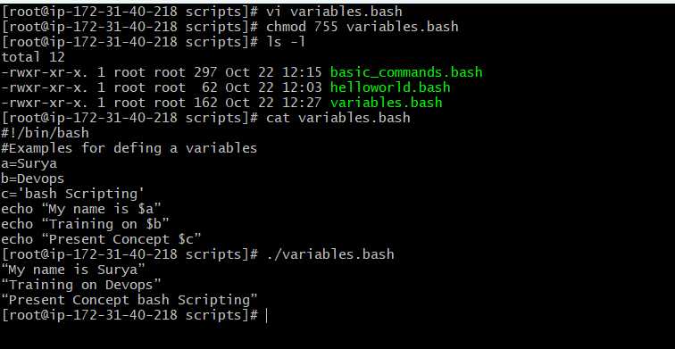

Read Input

#!/bin/bash
#Reading input from user
name=surya
echo “My name is $name”
read city
echo “Enter the City name”
echo $city

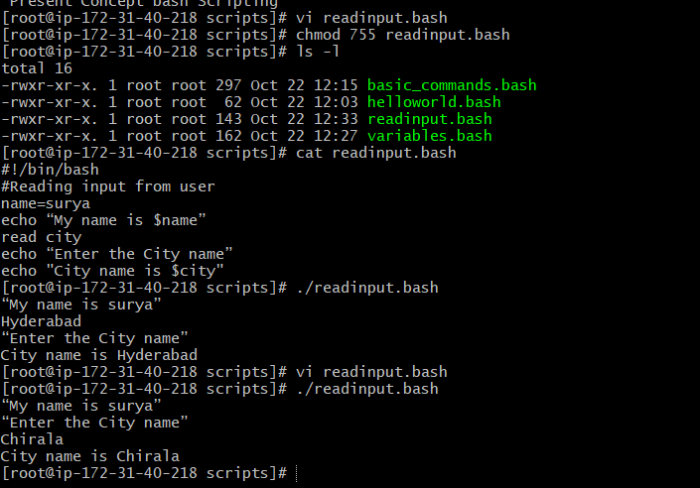

Scripts to run commands within

#!/bin/bash
# Script to run commands within tick marks(‘ ‘)

clear
echo "Hello `whoami`"
echo
echo "Today is `date`"
echo
echo "Number of user login: `who | wc -l `"
echo

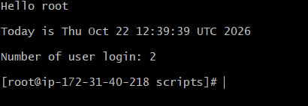

Read input and perform a task

#!/bin/bash
# This script will rename a file

echo Enter the file name to be renamed
read oldfilename

echo Enter the new file name
read newfilename

mv $oldfilename $newfilename
echo The file has been renamed as $newfilename

